ACTIVITIES - BUNSEN BURNER

Remember the following sequence for lighting and using a Bunsen burner.

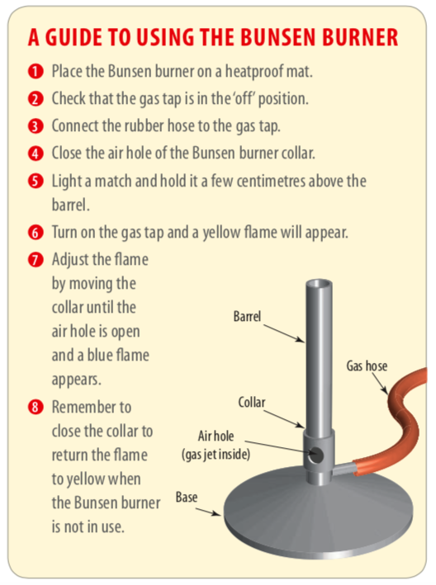

Try the following activities. Remember to apply safety precautions.

Answer the questions for each activity on the following page.

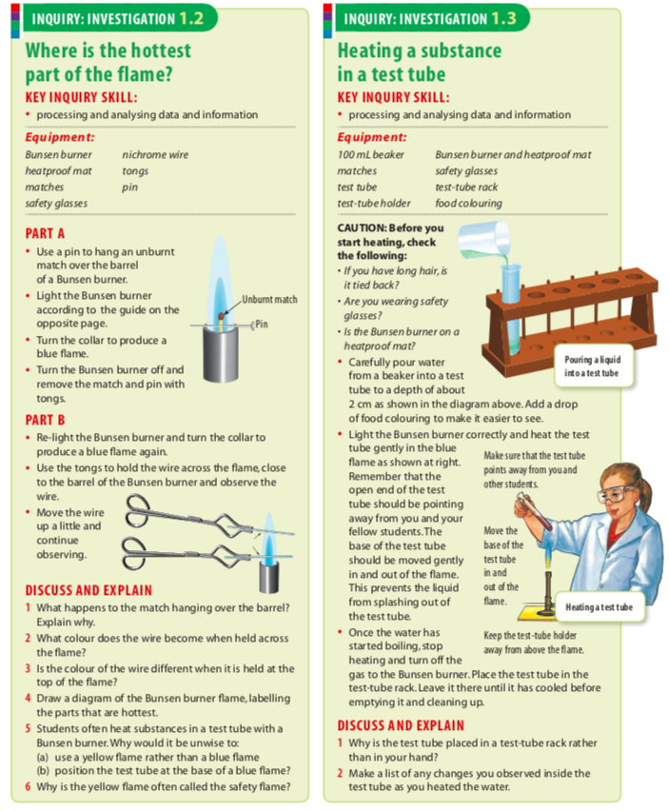

Discuss and Explain

